SQL Expressions

🌟 Definition
# Source: AI Source: Provided by: [Data Path: Persons Table -> ID Column: 1, Name_En Column: Motasem Essam] -> From: [ChatGPT] on [6/11/2026]
A SQL Expression is a combination of values, columns, operators, functions, and SQL keywords that SQL evaluates to produce a single value.
Expressions are used to calculate results, compare values, manipulate data, and build conditions in SQL queries.

🎯 Purpose
# Source: AI Source: Provided by: [Data Path: Persons Table -> ID Column: 1, Name_En Column: Motasem Essam] -> From: [ChatGPT] on [6/11/2026]
SQL expressions are used to:
- Perform calculations
- Compare values
- Concatenate text
- Create computed columns
- Filter records
- Sort query results
- Build conditions

🧠 Simple Example
# Source: AI Source: Provided by: [Data Path: Persons Table -> ID Column: 1, Name_En Column: Motasem Essam] -> From: [ChatGPT] on [6/11/2026]
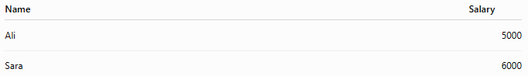
Employees Table
Name | Salary
Ali | 5000
Sara | 6000

SQL Statement
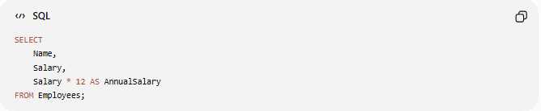
SELECT
Name,
Salary,
Salary * 12 AS AnnualSalary
FROM Employees;

Result
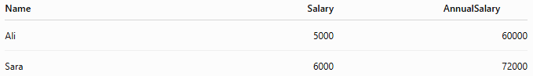
Name | Salary | AnnualSalary
Ali | 5000 | 60000
Sara | 6000 | 72000
The expression:
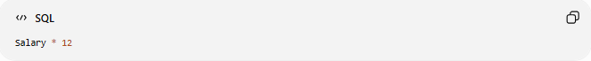
Salary * 12
calculates the annual salary.

📝 Syntax
# Source: AI Source: Provided by: [Data Path: Persons Table -> ID Column: 1, Name_En Column: Motasem Essam] -> From: [ChatGPT] on [6/11/2026]
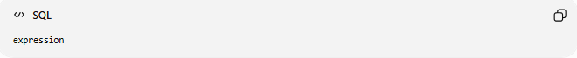
expression
An expression can include:
- Constants
- Columns
- Operators
- Functions
- CASE expressions

🔢 Components of a SQL Expression
# Source: AI Source: Provided by: [Data Path: Persons Table -> ID Column: 1, Name_En Column: Motasem Essam] -> From: [ChatGPT] on [6/11/2026]
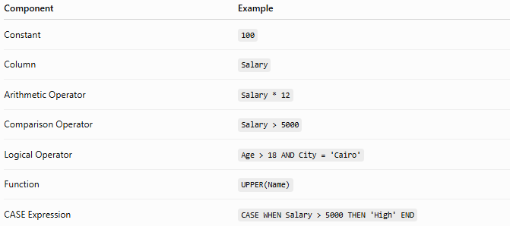
Component | Example
Constant | 100
Column | Salary
Arithmetic Operator | Salary * 12
Comparison Operator | Salary > 5000
Logical Operator | Age > 18 AND City = 'Cairo'
Function | UPPER(Name)
CASE Expression | CASE WHEN Salary > 5000 THEN 'High' END

🔹 Types of SQL Expressions
# Source: AI Source: Provided by: [Data Path: Persons Table -> ID Column: 1, Name_En Column: Motasem Essam] -> From: [ChatGPT] on [6/11/2026]
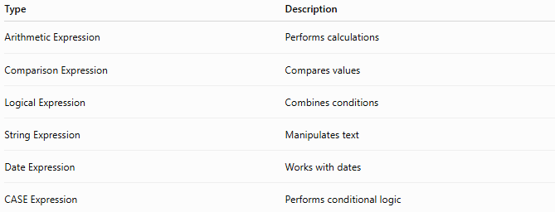
Type | Description
Arithmetic Expression | Performs calculations
Comparison Expression | Compares values
Logical Expression | Combines conditions
String Expression | Manipulates text
Date Expression | Works with dates
CASE Expression | Performs conditional logic

1️⃣ Arithmetic Expressions
# Source: AI Source: Provided by: [Data Path: Persons Table -> ID Column: 1, Name_En Column: Motasem Essam] -> From: [ChatGPT] on [6/11/2026]
Perform mathematical calculations.
Example
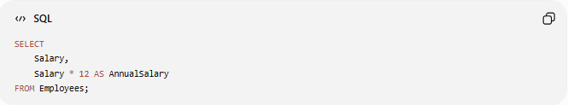
SELECT
Salary,
Salary * 12 AS AnnualSalary
FROM Employees;

Another Example
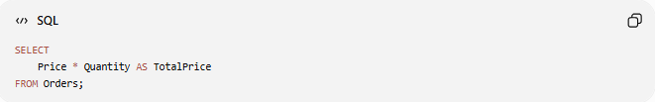
SELECT
Price * Quantity AS TotalPrice
FROM Orders;

2️⃣ Comparison Expressions
# Source: AI Source: Provided by: [Data Path: Persons Table -> ID Column: 1, Name_En Column: Motasem Essam] -> From: [ChatGPT] on [6/11/2026]
Compare two values.
Example
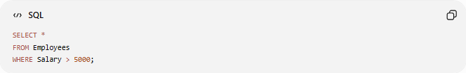
SELECT *
FROM Employees
WHERE Salary > 5000;
Comparison expression:
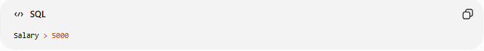
Salary > 5000

3️⃣ Logical Expressions
# Source: AI Source: Provided by: [Data Path: Persons Table -> ID Column: 1, Name_En Column: Motasem Essam] -> From: [ChatGPT] on [6/11/2026]
Combine multiple conditions.
Example
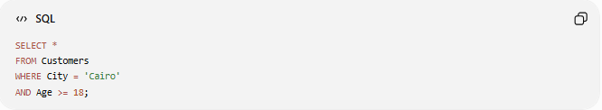
SELECT *
FROM Customers
WHERE City = 'Cairo'
AND Age >= 18;
Logical expression:
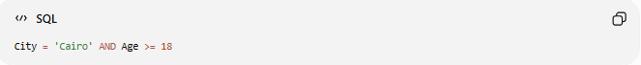
City = 'Cairo' AND Age >= 18

4️⃣ String Expressions
# Source: AI Source: Provided by: [Data Path: Persons Table -> ID Column: 1, Name_En Column: Motasem Essam] -> From: [ChatGPT] on [6/11/2026]
Manipulate text values.
Example
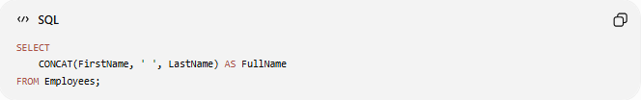
SELECT
CONCAT(FirstName, ' ', LastName) AS FullName
FROM Employees;

Result
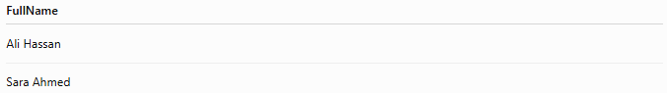
FullName
Ali Hassan
Sara Ahmed

5️⃣ Date Expressions
# Source: AI Source: Provided by: [Data Path: Persons Table -> ID Column: 1, Name_En Column: Motasem Essam] -> From: [ChatGPT] on [6/11/2026]
Perform calculations or formatting with dates.
Example
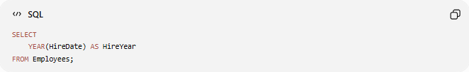
SELECT
YEAR(HireDate) AS HireYear
FROM Employees;

6️⃣ CASE Expressions
# Source: AI Source: Provided by: [Data Path: Persons Table -> ID Column: 1, Name_En Column: Motasem Essam] -> From: [ChatGPT] on [6/11/2026]
Use conditional logic inside a query.
Example
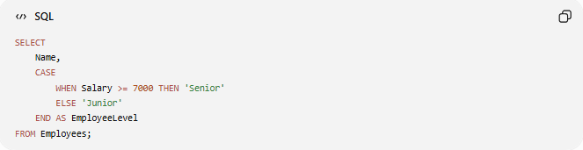
SELECT
Name,
CASE
WHEN Salary >= 7000 THEN 'Senior'
ELSE 'Junior'
END AS EmployeeLevel
FROM Employees;

Another Example
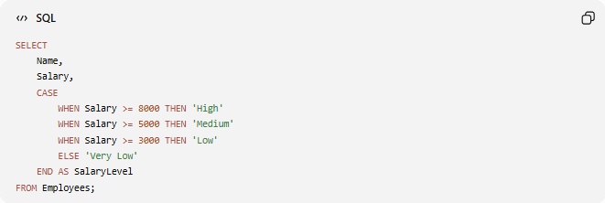
SELECT
Name,
Salary,
CASE
WHEN Salary >= 8000 THEN 'High'
WHEN Salary >= 5000 THEN 'Medium'
WHEN Salary >= 3000 THEN 'Low'
ELSE 'Very Low'
END AS SalaryLevel
FROM Employees;

📚 Expressions in Different SQL Clauses
# Source: AI Source: Provided by: [Data Path: Persons Table -> ID Column: 1, Name_En Column: Motasem Essam] -> From: [ChatGPT] on [6/11/2026]
SELECT
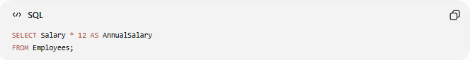
SELECT Salary * 12 AS AnnualSalary
FROM Employees;

WHERE
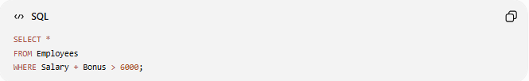
SELECT *
FROM Employees
WHERE Salary + Bonus > 6000;

ORDER BY
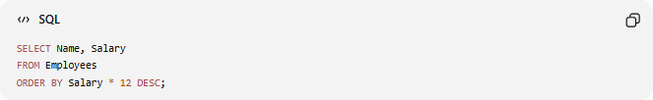
SELECT Name, Salary
FROM Employees
ORDER BY Salary * 12 DESC;

GROUP BY
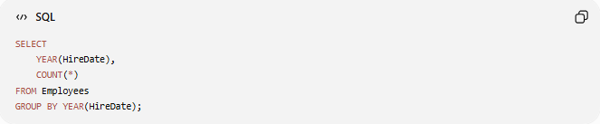
SELECT
YEAR(HireDate),
COUNT(*)
FROM Employees
GROUP BY YEAR(HireDate);

HAVING
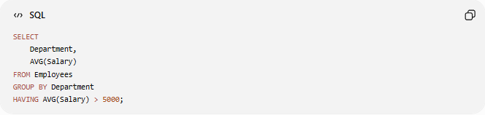
SELECT
Department,
AVG(Salary)
FROM Employees
GROUP BY Department
HAVING AVG(Salary) > 5000;

🛠️ Complete Test Example

1️⃣ Create Table
# Source: AI Source: Provided by: [Data Path: Persons Table -> ID Column: 1, Name_En Column: Motasem Essam] -> From: [ChatGPT] on [6/11/2026]
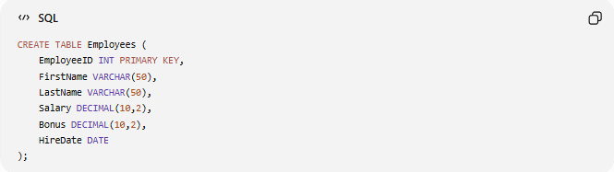
CREATE TABLE Employees (
EmployeeID INT PRIMARY KEY,
FirstName VARCHAR(50),
LastName VARCHAR(50),
Salary DECIMAL(10,2),
Bonus DECIMAL(10,2),
HireDate DATE
);

2️⃣ Insert Sample Data
# Source: AI Source: Provided by: [Data Path: Persons Table -> ID Column: 1, Name_En Column: Motasem Essam] -> From: [ChatGPT] on [6/11/2026]
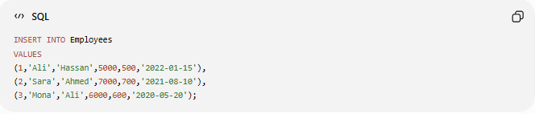
INSERT INTO Employees
VALUES
(1,'Ali','Hassan',5000,500,'2022-01-15'),
(2,'Sara','Ahmed',7000,700,'2021-08-10'),
(3,'Mona','Ali',6000,600,'2020-05-20');

3️⃣ Arithmetic Expression
# Source: AI Source: Provided by: [Data Path: Persons Table -> ID Column: 1, Name_En Column: Motasem Essam] -> From: [ChatGPT] on [6/11/2026]
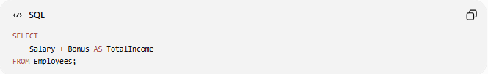
SELECT
Salary + Bonus AS TotalIncome
FROM Employees;

4️⃣ String Expression
# Source: AI Source: Provided by: [Data Path: Persons Table -> ID Column: 1, Name_En Column: Motasem Essam] -> From: [ChatGPT] on [6/11/2026]
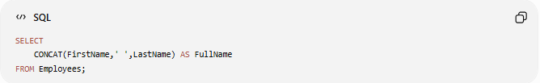
SELECT
CONCAT(FirstName,' ',LastName) AS FullName
FROM Employees;

5️⃣ CASE Expression
# Source: AI Source: Provided by: [Data Path: Persons Table -> ID Column: 1, Name_En Column: Motasem Essam] -> From: [ChatGPT] on [6/11/2026]
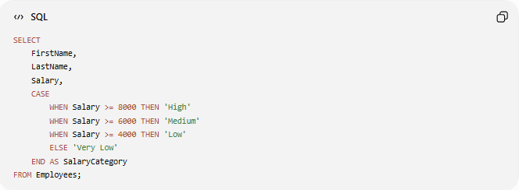
SELECT
FirstName,
LastName,
Salary,
CASE
WHEN Salary >= 8000 THEN 'High'
WHEN Salary >= 6000 THEN 'Medium'
WHEN Salary >= 4000 THEN 'Low'
ELSE 'Very Low'
END AS SalaryCategory
FROM Employees;

Real Example

prepared commands

1️⃣ Create Table
# Source: ScreenShot Source: Provided by: [Persons Table -> ID Column: 1, Name_En Column: Motasem Essam] -> Tool: [Automation Table -> ID Column: 16, Name_En Column: Screen Capture] -> From [Operating System: Wampserver64 -> phpmyadmin] on [6/11/2026]
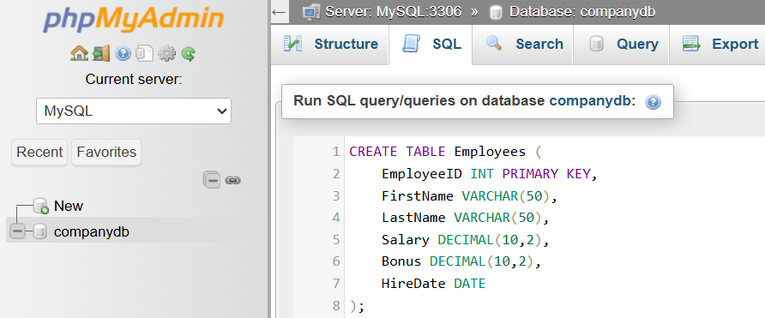
CREATE TABLE Employees (
EmployeeID INT PRIMARY KEY,
FirstName VARCHAR(50),
LastName VARCHAR(50),
Salary DECIMAL(10,2),
Bonus DECIMAL(10,2),
HireDate DATE
);
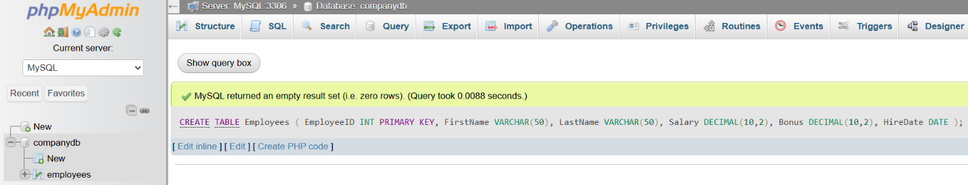

2️⃣ Insert Sample Data
# Source: ScreenShot Source: Provided by: [Persons Table -> ID Column: 1, Name_En Column: Motasem Essam] -> Tool: [Automation Table -> ID Column: 16, Name_En Column: Screen Capture] -> From [Operating System: Wampserver64 -> phpmyadmin] on [6/11/2026]
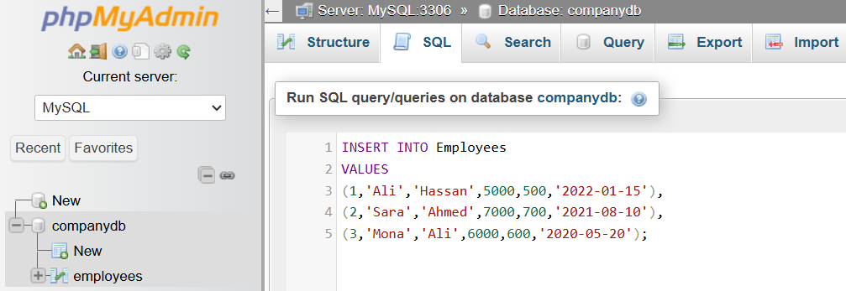
INSERT INTO Employees
VALUES
(1,'Ali','Hassan',5000,500,'2022-01-15'),
(2,'Sara','Ahmed',7000,700,'2021-08-10'),
(3,'Mona','Ali',6000,600,'2020-05-20');
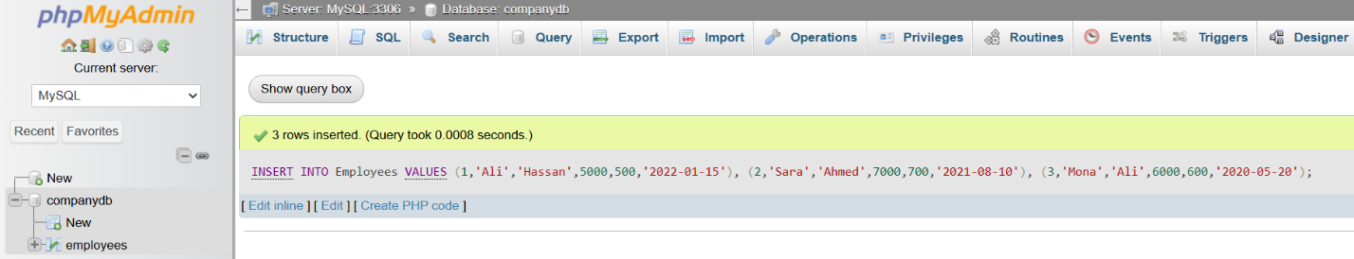

basic command

3️⃣ Arithmetic Expression
# Source: ScreenShot Source: Provided by: [Persons Table -> ID Column: 1, Name_En Column: Motasem Essam] -> Tool: [Automation Table -> ID Column: 16, Name_En Column: Screen Capture] -> From [Operating System: Wampserver64 -> phpmyadmin] on [6/11/2026]
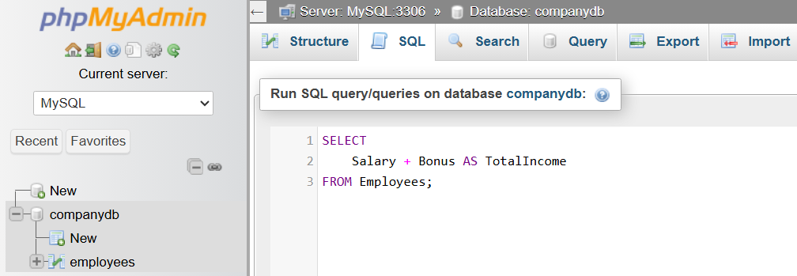
SELECT
Salary + Bonus AS TotalIncome
FROM Employees;
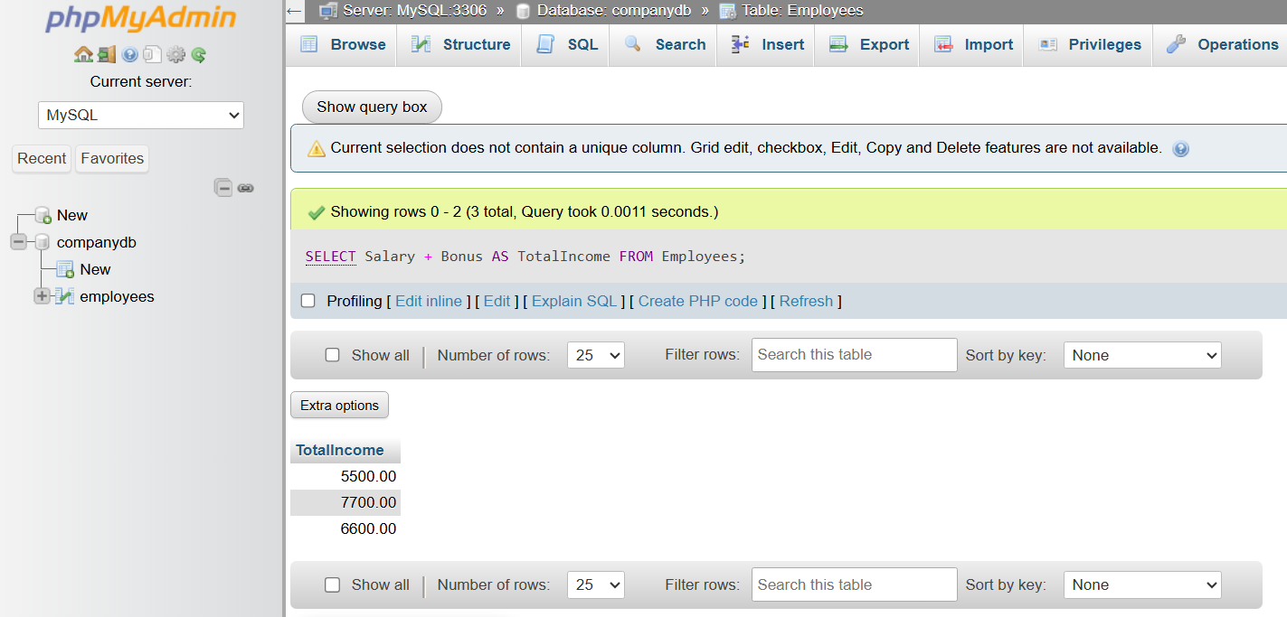

4️⃣ String Expression
# Source: ScreenShot Source: Provided by: [Persons Table -> ID Column: 1, Name_En Column: Motasem Essam] -> Tool: [Automation Table -> ID Column: 16, Name_En Column: Screen Capture] -> From [Operating System: Wampserver64 -> phpmyadmin] on [6/11/2026]
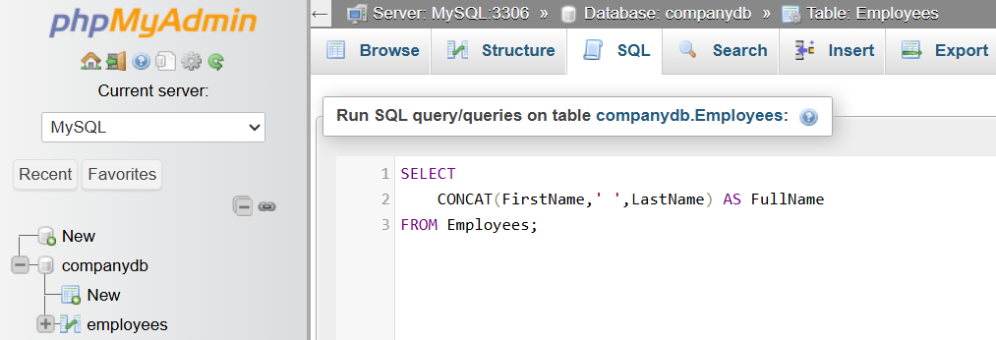
SELECT
CONCAT(FirstName,' ',LastName) AS FullName
FROM Employees;
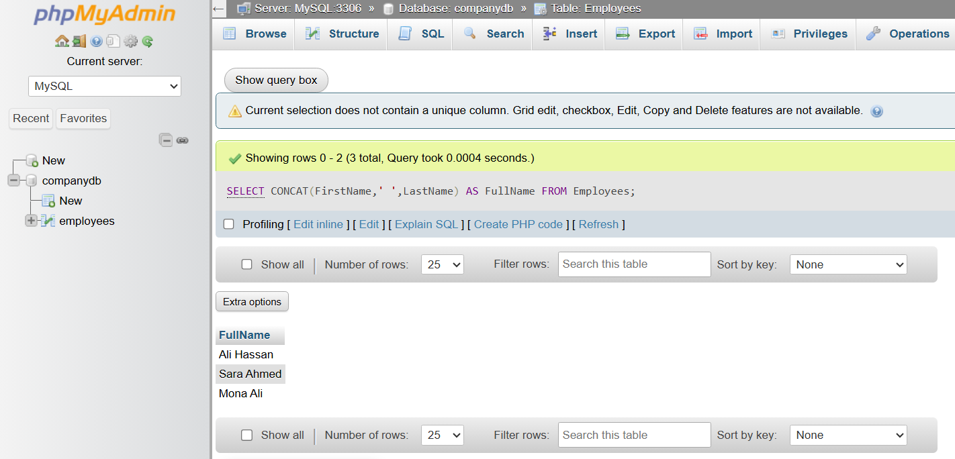

5️⃣ CASE Expression
# Source: ScreenShot Source: Provided by: [Persons Table -> ID Column: 1, Name_En Column: Motasem Essam] -> Tool: [Automation Table -> ID Column: 16, Name_En Column: Screen Capture] -> From [Operating System: Wampserver64 -> phpmyadmin] on [6/11/2026]
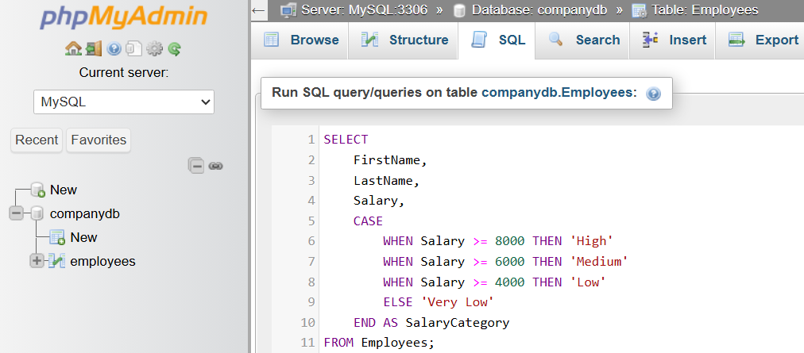
SELECT
FirstName,
LastName,
Salary,
CASE
WHEN Salary >= 8000 THEN 'High'
WHEN Salary >= 6000 THEN 'Medium'
WHEN Salary >= 4000 THEN 'Low'
ELSE 'Very Low'
END AS SalaryCategory
FROM Employees;
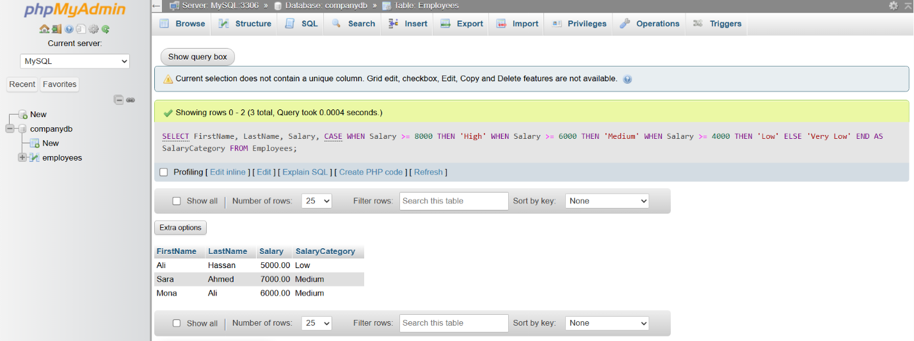

📊 Expressions vs Functions
# Source: AI Source: Provided by: [Data Path: Persons Table -> ID Column: 1, Name_En Column: Motasem Essam] -> From: [ChatGPT] on [6/11/2026]
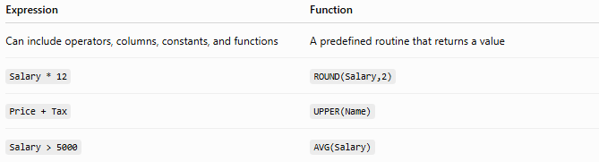
Expression | Function
Can include operators, columns, constants, and functions | A predefined routine that returns a value
Salary * 12 | ROUND(Salary,2)
Price + Tax | UPPER(Name)
Salary > 5000 | AVG(Salary)
A function is one type of expression, but not every expression is a function.

⚠️ Important Notes
# Source: AI Source: Provided by: [Data Path: Persons Table -> ID Column: 1, Name_En Column: Motasem Essam] -> From: [ChatGPT] on [6/11/2026]
- Every function call is an expression.
- Expressions can return numbers, text, dates, or Boolean results.
- Expressions are used throughout SQL, including in SELECT, WHERE, ORDER BY, GROUP BY, HAVING, and CASE.
- SQL evaluates expressions before returning the final query result.

🔢 SQL Expression Workflow
# Source: AI Source: Provided by: [Data Path: Persons Table -> ID Column: 1, Name_En Column: Motasem Essam] -> From: [ChatGPT] on [6/11/2026]
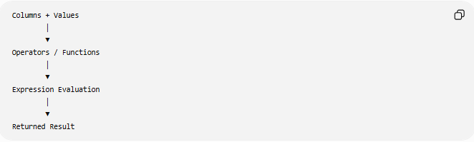
Columns + Values
│
▼
Operators / Functions
│
▼
Expression Evaluation
│
▼
Returned Result

🧠 Simple Analogy
# Source: AI Source: Provided by: [Data Path: Persons Table -> ID Column: 1, Name_En Column: Motasem Essam] -> From: [ChatGPT] on [6/11/2026]
Think of a calculator.
When you type:
10 + 5 × 2
the calculator evaluates the expression and returns a single result.
Similarly, in SQL:
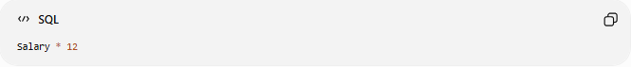
Salary * 12
SQL evaluates the expression and returns the annual salary.
Expressions are simply formulas that SQL computes to produce a value.

🧭 Summary
# Source: AI Source: Provided by: [Data Path: Persons Table -> ID Column: 1, Name_En Column: Motasem Essam] -> From: [ChatGPT] on [6/11/2026]
A SQL Expression is any valid combination of values, columns, operators, functions, and keywords that SQL evaluates to produce a single result. Expressions are the foundation of SQL queries and are used for calculations, comparisons, text manipulation, conditional logic, filtering, sorting, and data transformation across clauses such as SELECT, WHERE, ORDER BY, GROUP BY, and HAVING.

